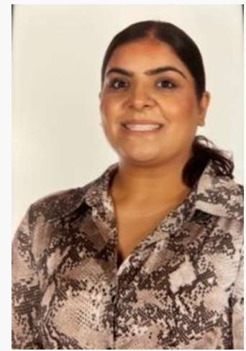
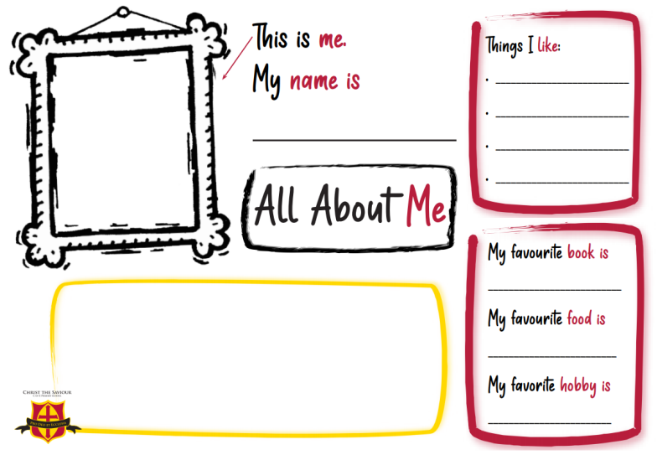

Miss Hira
Shopping
Cooking
Harry Potter Series
Hi, I’m Miss Hira and I am very excited to be your new Year 4 teacher next year. I’ve heard Year 4 is a great year a new change for you and me and there are lots of interesting topics to explore; I particularly like the Power of Reading texts were about to explore! I am very passionate about cooking and going to the gym. I enjoy going on long walks and having picnics. I can’t wait to hear everything about your amazing school holidays, and I look forward to September!
Going shopping
Japanese/ Chinese
Going Cinema
Gym

